**Date Submitted: 12/13/19**

**Goal:**

Goal of this assignment is to create three tasks:  
 1) ADC task, 2) UART display task, and 3) Switch Read task.

**------------------------------------------------------------------------------------**

**Implementation:**

Each task will be executed in order specified above every 30 ms. Connect a potentiometer to the ADC pin. Use ADC1 CH3. Also initialize a PWM signal to a LED (PF1). Initial value of the PWM dutycycle is set to 0. Create a timer 0/1/2 HWI for every 1 ms, at 10th instance of HWI the task ADC is performed, at 20th instance of HWI the task UART displays the current value ADC in the terminal, and at 30th instance of HWI the task Switch Read is performed to check the status of the SW1/SW2 to update the current value of dutycycle based on the ADC value. Note that the dutycycle of the PWM does not change unless the switch is pressed, even when the ADC value changes. However, the UART should display the dynamic value of the ADC.

**------------------------------------------------------------------------------------**

**Schematics:**

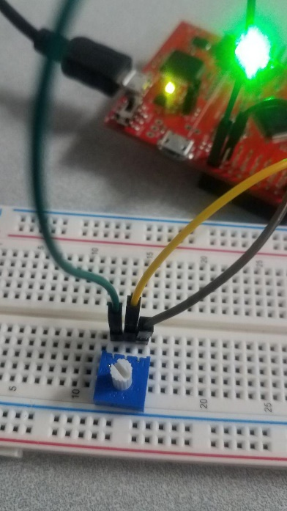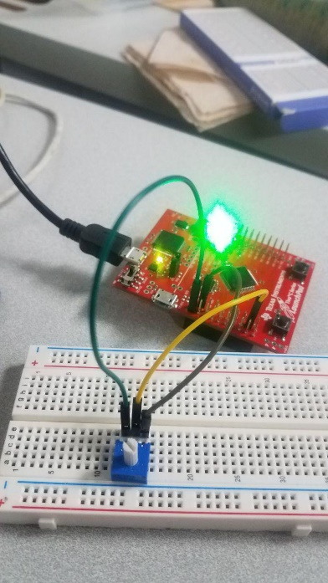

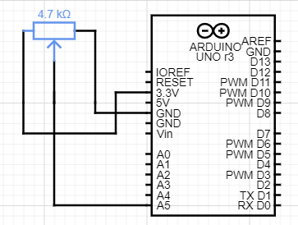

**Through this is labeled as an Arduino uno, it’s actually a TivaC but I was not able to find the schematic for this device in the software I was using. Instead of being connected to A5, it was connected PA6.**

**------------------------------------------------------------------------------------**

**Video Link:**

**https://youtu.be/Nw1LToy6jl8**

**------------------------------------------------------------------------------------**

**Screenshots:**

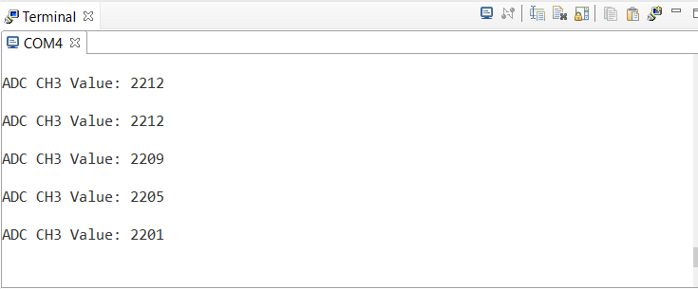

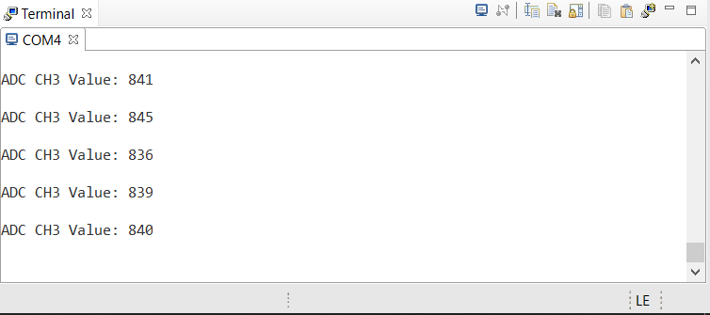

**------------------------------------------------------------------------------------**

**Conclusions(tasks completed):**

In the end, I was only able to get the first two tasks to work but worked well.